DevOps Project 1

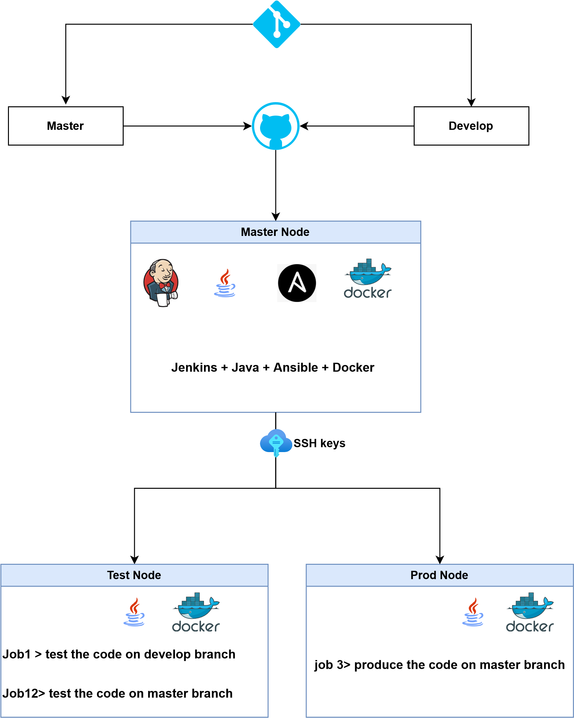

* Using Ansible for configuration management for master-slave architecture
* Git workflow show should be implemented
* Code build should be automatically triggered once the commit is made from the master branch and develop branch
* Integrating Git and Jenkins for automated pipeline
* Including the Develop branch for testing the Docker file and the Master branch for testing the final version of the Docker file
* Production Server for the final release of the product